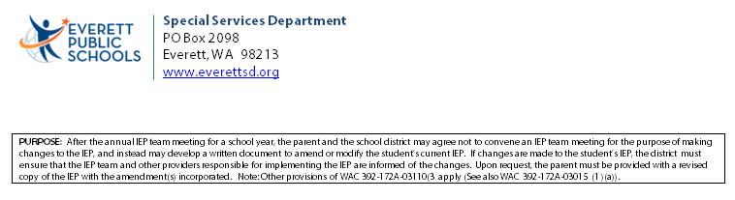

|  |  |
| --- | --- |
| Date of Amendment: | Amendment of the IEP dated: |
| Student Name: | Student ID: |

**Riser IEP Amendment**

This IEP amendment revises or modifies: *(Check all that apply)*

|  |  |
| --- | --- |
| Present levels of educational achievement and functional performance.  Instructional goals and objectives.  Frequency, location, and/or duration of special education services provided.  Related services.  Supplementary aids/services, accommodations, and/or transportation.  State and/or district assessment participation and/or testing accommodations.  Transition services. | |
| Other: | Riser paperwork for the 2020_2021 School Year |

**Description of the Proposed Revision(s)** *(attach revised goal pages or other IEP pages as may be appropriate)*

The IEP is being amended to change student’s Preschool placement to  AM or  PM

The IEP is being amended to change the student’s placement to reflect change from Preschool to Developmental DK.

The IEP is being amended to reflect the natural transition from Elementary school to Middle School

The IEP is being amended to reflect the natural transition from Middle school to High School

The IEP is being amended to reflect minute and program change to

The IEP is being amended to reflect the natural transition to Goal or Strive

Other:

Description:

***Student Name:***

|  |  |  |  |  |  |
| --- | --- | --- | --- | --- | --- |
| **Service** | **Initiation Date** | Frequency | Location of Service | Duration | **Staff Responsible for Delivering Service** |
| **Special Education** *(specially designed instruction):* | | | | | |
| Cognitive Functioning | 09/05/2020 |  | Special Education/SDI |  | Special Education Teacher |
| Reading | 09/05/2020 |  | Special Education/SDI |  | Special Education Teacher |
| Written Expression | 09/05/2020 |  | Special Education/SDI |  | Special Education Teacher |
| Math | 09/05/2020 |  | Special Education/SDI |  | Special Education Teacher |
| Vocational | 09/05/2020 |  | Special Education/SDI |  | Special Education Teacher |
| Personal Social Behavioral | 09/05/2020 |  | Special Education/SDI |  | Special Education Teacher |
| Adaptive/Self-Help | 09/05/2020 |  | Special Education/SDI |  | Special Education Teacher |
| Communication Skills | 09/05/2020 |  | Special Education/SDI |  | Speech Language Pathologist |
| Gross/Fine Motor | 09/05/2020 |  | Special Education/SDI |  | Occupational / Physical Therapist |
| Other | 09/05/2020 |  | Special Education/SDI |  |  |
| Other | 09/05/2020 |  | Special Education/SDI |  |  |
| **Related Services** *(i.e. – speech, motor, counseling, vision/hearing, transportation, interpreting services, orientation/mobility, parent training, etc.):* | | | | | |
| Transportation | 09/05/2020 | To School | Bus | To home | Bus Driver |
| OT/PT related services | 09/05/2020 |  |  |  | Occupational / Physical Therapist |
| Communication Related | 09/05/2020 |  |  |  | Speech Language Pathologist |
| Shared Para | 09/05/2020 |  |  |  | Shared Para |
| 1:1 Para | 09/05/2020 |  |  |  | 1:1 Para |
| 2 Shared Para | 09/05/2020 |  |  |  | 2 Shared Para |
| 1:1 Nurse | 09/05/2020 |  |  |  | 1:1 Nurse |
| 1:1 Interpreter | 09/05/2020 |  |  |  | 1:1 Interpreter |
| Other | 09/05/2020 |  |  |  |  |

Parent/Guardian____________________________________ Parent/Guardian ___________________________

Student _____________________________________________ Special Education Staff__________________________

Special Education Staff_____________________________ Special Education Staff__________________________